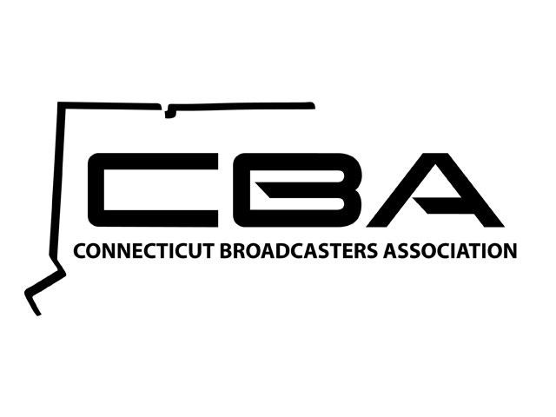

Dear [members of the Connecticut delegation to Congress]:

As local television and radio broadcast stations across Connecticut, we write in support of the ongoing congressional effort to reform the nation’s tax code. In particular, we support the current House Blueprint’s preservation of tax deductibility of advertising as part of its effort to stimulate economic growth. As Congress considers the House Blueprint and other tax reform proposals, we urge you to recognize that any modification to the current tax treatment of advertising poses significant economic harm to our local advertising partners and, by extension, our investment in local news, weather, sports, civic information, and service in the local communities you represent.

For over a century, Congress has treated advertising as a fully deductible cost of doing business because, like salaries, rent, utilities, and office supplies, it is an ordinary and necessary business expense. As you consider potential reforms to our nation’s tax system, we support your efforts to simplify the code, strengthen the economy, and make America more competitive. However, any limitations to the full, first-year deductibility of advertising will have the effect of making the tax code more complicated, slowing an engine of economic growth and job creation, and undermining the U.S. advertising and broadcasting economy.

Advertising accounts for almost one-fifth of our national GDP, over $5 trillion in domestic sales, and roughly 20 million U.S. jobs. For every dollar spent on advertising, an additional $19 of economic activity is generated. In Connecticut, advertising helps generate over $89 billion in economic activity and helps produce nearly 300,000 jobs. Local broadcasters see this economic super-charging through advertising partners in our hometowns every day. Their connection to consumers ultimately supports investment and jobs in the stores along Main Street, in the factories and manufacturing centers, and in the coffee shops and restaurants that are the economic heartbeat of our communities.

In addition to the direct harm posed to Connecticut businesses that rely on advertising to sell their products and services, any limitation to full deductibility will also harm local television and radio broadcasters like us for whom advertising is the primary – if not only – source of revenue.
Broadcasters rely on this advertising revenue to produce and deliver vital local and national news, emergency information and high-quality entertainment to our local communities free of charge. Nationwide, broadcast stations generate more than $1.19 trillion in economic activity and support 2.49 million jobs in all sectors, including auto dealers, banks, retail stores, and real estate brokers, among many others. In Connecticut, broadcasters’ create an economic impact of $14 billion and over 27,000 jobs. Creating a disincentive to advertise has real consequences on the ability of broadcast stations to serve our communities with local programming and contribute to our hometown economies.

On behalf of our advertising partners, the employees and families we collectively support, and the listeners and viewers of local broadcast radio and television stations, we urge you to reject any changes to the full, first-year deductibility of advertising. Sincerely,

